# COMP3000 Computing Project

## 2024/2025

### Project Title: SkinSensor (Temporary Name)

### Links

Source code:<https://github.com/kdhruv1/SkinSensor>

Project Management: <https://trello.com/b/j2JqIHwg/comp3000final-project>

### Project Vision

*Background and Problem*

*Skin Related Issues and diseases affects millions of people worldwide which can have significant impacts on quality of life. According to* World Health Organization (WHO), skin infections affect 1.8 billion people at any point in time. *Globally skin diseases are the fourth most common cause of all human diseases affecting one-third of the world’s population, yet their burden in quality and impact of human life is often underestimated.*

*Considering this early detection of skin conditions such as melanoma or skin cancer significantly improves the chances of treatment being successful, however due to the recent Covid-19 pandemic and access to dermatologists both in first and third world countries being limited a cheap and portable option is necessary.*

*Solution*

*My Proposed solution SkinSensor aims to provide an accessible, portable solution for detecting skin diseases through a mobile application that uses AI-based image analysis. The Application allows users to capture images of skin conditions such as moles or rashes for early diagnosis of potential skin concerns. By train and testing the Neural Network using a large reliable dataset the app will provide accurate diagnosis within seconds without having the need to consult a dermatologist. Based of this feedback the Application will also provide information for treatment on skin issues or recommendation to dermatologists.*

*Target Audience*

*SkinSensor is designed for individuals aged 18 and above, particularly those who have skin-related concerns and may not have easy access to dermatologists. This includes users from low-income communities and regions with limited medical resources where professional healthcare is limited.*

*Problems Addressed*

*SkinSensor provides a solution to the accessibility of reliable skin diagnosis by providing a fast, user friendly and portable solution. Users no longer have delays seeking medical advice or struggle to access to dermatologist for skin concerns. Additionally, Skin sensor helps reduce strain on dermatologist that may have occurred from Covid-19 when medical help was not readily available by allowing users to perform a preliminary diagnosis before seeking medical advice.*

*Project Methodology*

*For the Project Agile Methodology will be used, agile methodology is an iterative and incremental approach to software development providing flexibility in the project as key features and timelines are not fixed. It’s designed for project with changing requirements and have fast delivery times compared to other methodologies, making it ideal for this project where supervisor meetings take place bi-weekly.*

*Advantages*

* *Flexibility*
* *High quality*
* *Fast delivery*

*Project/Application Requirements*

* *User Login and Sign-Up Features*
* *Normalised Dataset and Data (remove any medical data or user data)*
* *Allow Images to be Uploaded or taken by user camera.*
* *Accurate AI and Neural network model*
* *Fast Diagnosis*
* *Accessible and easy to use user interface.*
* *Skin treatment or medical recommendation information*
* *Multi-platform capability*

*Key Features*

* *Fast Diagnosis: The AI will be able to analyse an image and deliver a diagnosis within 40 seconds.*
* *Affordable: The App is free to use, ensuring accessibility for everyone*
* *Secure and Private: All data is securely stored, and the app ensures user anonymity by stripping metadata and removing any identifying features.*
* *Reliable Diagnosis: Trained on a reliable dataset with over 30,000 samples, the app provides accurate diagnostic predictions with a confidence rating.*
* *Portable: As the Solution is a mobile application, it can be users anywhere, anytime, across the globe.*
* *User friendly: The Application will be designed to have an easy-access navigation menu and design ensuring ease for all users.*
* *Accessibility: The application will include accessibility features such as colour-blind mode and customisable display options to accommodate users with diverse needs ensuring inclusivity*

### Risk Plan

|  |  |  |  |  |  |  |
| --- | --- | --- | --- | --- | --- | --- |
| Risk Number /name | Risk Cause | Risk Effect | Likelihood (almost certain, likely, possible, unlikely or rare) | Consequences (negligible, minor, moderate, major, crucial) | Risk Ranking (low, moderate, high, very high) | Mitigation |
| 1 Anonymity | Potential Identifying features are removed when user upload images (meta data, facial features, tattoos etc) | Having images revealing users can breach image right laws and privacy laws | Likely: High chance of uploaded images having meta data or revealing features for example face acne | Crucial: As the images are stored, this can have risks of being stolen which may lead to breach in user privacy resulting in heavy fines | Very high | Implement techniques to remove image metadata, mask body parts, and obfuscate facial features. |
| 2 User Data | When using online datasets, personal user data (e.g., name age, gender) must not be stored | Having personal records of individuals on a data can risk data protection laws and the common law duty of confidentiality. | Likely: When importing datasets there is a high chance of the data being unnormalized | Crucial: holding sensitive data can risk data protection laws | Very high | Before Training the AI, normalise and anonymise data ensuring that personal information is not stored |
| 3: Data storage | Uploaded images will be stored in the application along with diagnosis for users to view later. | Image and diagnosis data being stored can risk in theft of data | Likely: The chances of images and diagnosis being stored will be likely as this will be a feature of the app | Negligible: Although images and diagnosis will be stored, the data contained will not hold any personal data that is valuable. | Low | When storing images and diagnoses, implement encryption and security protocols |
| 4: User Permissions | The application will use the users’ cameras to which the app will need camera permissions as well as storage permission to store data | Having camera access and Storage without having permission can breach privacy laws | Unlikely: Application requests user permission before App is used | Major: Accessing storage and camera without having permissions can breach privacy laws resulting in a fine. | Moderate | New users are requested to allow camera and storage permissions when first using the app |
| 5: Risk of Computational power for AI Algorithm's | Both when training the datasets and users running the application the devices used must have minimum computational power for the AI to run the algorithm | Insufficient computational power can result in a slower diagnosis or app crashing | Unlikely: The likelihood of insufficient computational among users is unlikely as most devices now have optimal hardware whilst the AI algorithm will use only a small snippet of the dataset reduce time needed to train. | Major: Insufficient computational power can have great effects on the application as it can significantly reduce diagnosis speed or even crash the app causing user dissatisfaction | Moderate | To optimise the App, implement efficient algorithms whilst using model compression techniques such as pruning to reduce computational load. |

### User UML diagram

### Below is a small diagram of how the user will interact with the application.

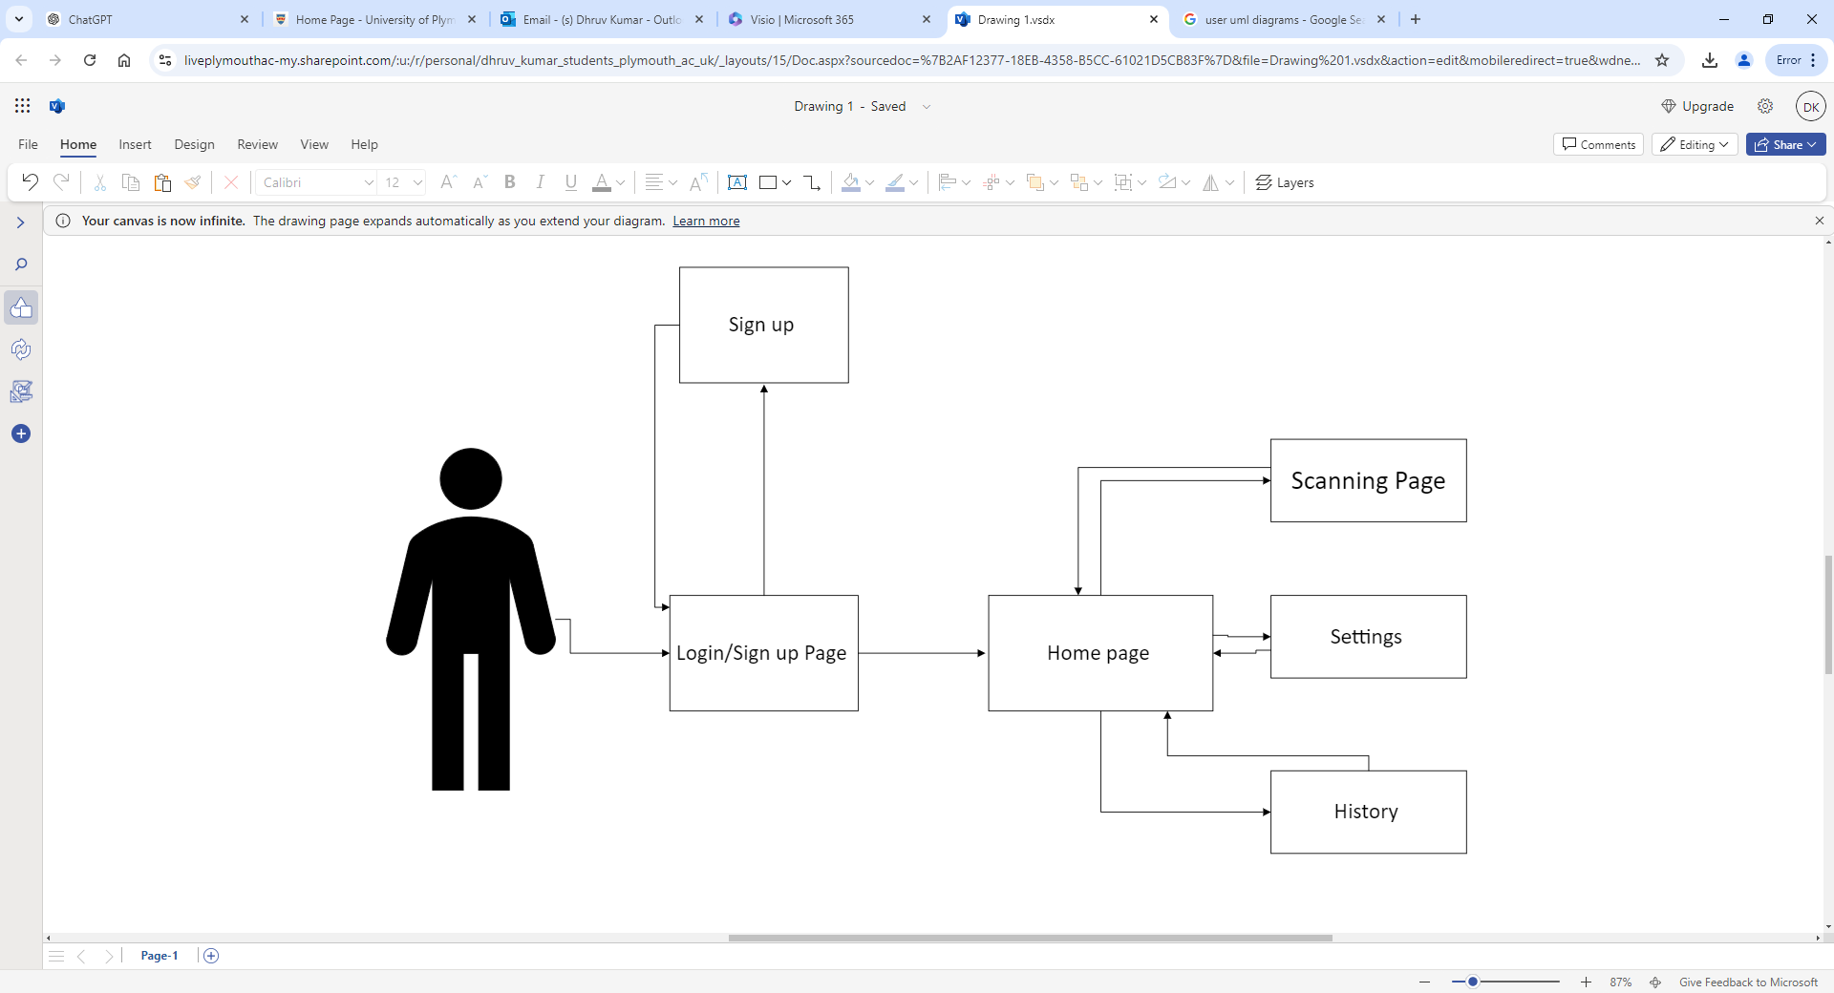

### Proposed Gantt chart

Above is my Proposed Sprint/Project Plan for Semester 1, in the Gantt chart above I’ve listed key sprints and their core tasks to be completed in each of them.

Sprint 0: This sprint ranges from the start of the year to early November when the project is in its infancy and objectives/requirements are being set. At this stage designing is also mainly done so that later sprints are not delayed.

Sprint 1: During this sprint, I will start to develop the login page of the app whilst starting to normalise the imported dataset in Jupiter.

During test, I will test to make sure that the login page functions as well ensuring medical data is removed from the dataset.

Sprint 2: In this sprint I will continue developing the app by creating the home page whilst starting to train and test the dataset.

During test, I will test to make sure navigation between the login page and home page functions as well as test the accuracy of the AI.

Sprint 3: Before breaking off for winter break, I will develop the core scanning feature of the app by integrating the AI model with the Scanning page. After which I will test the camera functions using my phone and the accuracy of the AI diagnosis.

### Trello

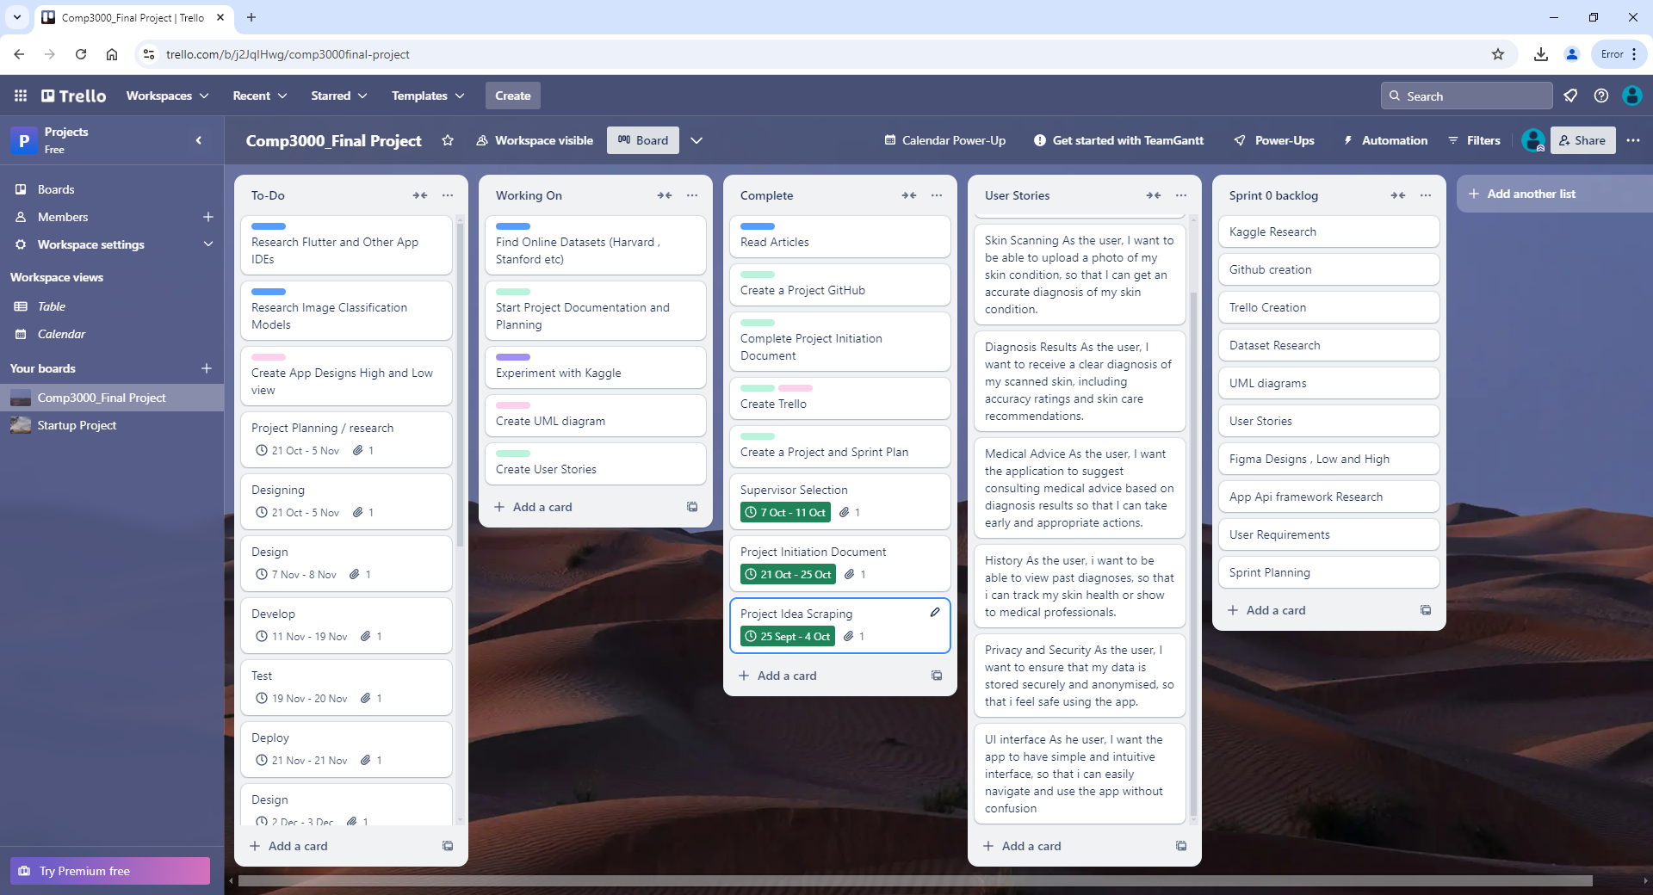



Project Backlog Sprint 0

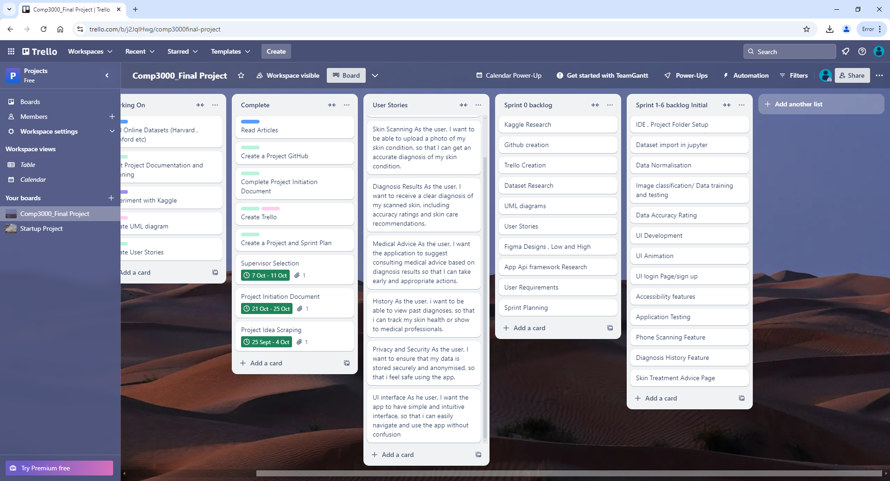

Project Backlog Sprint 1-6

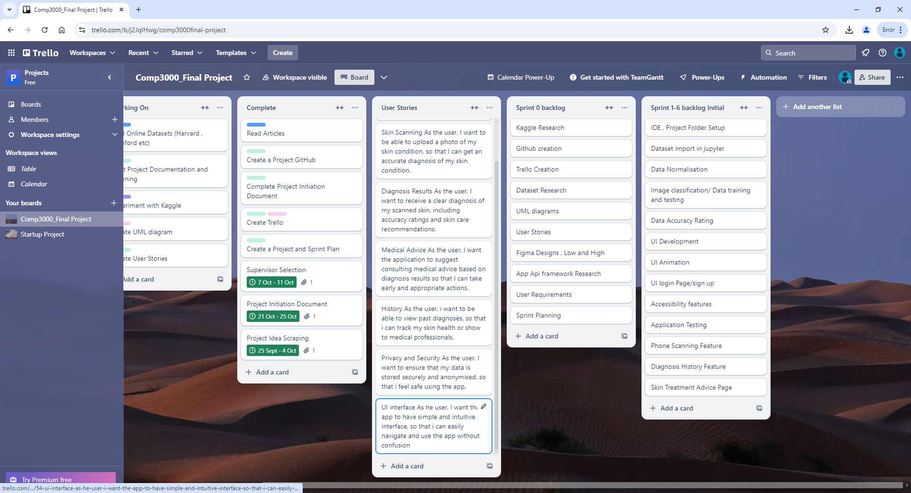

### User Stories:

User Login

As the User, I want to be able to create and account and log in securely, so that I can access my scanning history.

Skin Scanning

As the user, I want to be able to upload a photo of my skin condition, so that I can get an accurate diagnosis of my skin condition.

Diagnosis Results

As the user, I want to receive a clear diagnosis of my scanned skin, including accuracy ratings and skin care recommendations.

Medical Advice

As the user, I want the application to suggest consulting medical advice based on diagnosis results so that I can take early and appropriate actions.

History

As the user, I want to be able to view past diagnoses, so that i can track my skin health or show to medical professionals.

Privacy and Security

As the user, I want to ensure that my data is stored securely and anonymised, so that i feel safe using the app.

UI interface

As he user, I want the app to have simple and intuitive interface, so that i can easily navigate and use the app without confusion.

Resource Plan:

* GitHub: A version control system will be used to manage the codebase of the project. GitHub will be used to ease tracking through different sprint pushes and enable control of earlier application versions in case of unstable releases.
* Trello: Trello will be uses and the projects management tool to organise task, track progress and allow transparency of project progress from supervisor to individual.
* Team Gantt: A Gantt chart will be created to visually represent the project sprint timeline as well as include key milestones.
* Visual Studio: Visual studio will be used as the IDE (integrated Development Environment) for coding, debugging and testing of the application.
* Flutter API: The Flutter framework will be implemented to develop the mobile application allowing for an accessible user interface.
* Online Dataset for Skin diseases: An online dataset will be sourced to train and test the AI model to be used in the SkinSensor application. The dataset will be diverse containing various skin diseases from different ethnicities ensuring accurate diagnoses.
* Microsoft Teams: To facilitate sprint meetings between supervisor and myself Microsoft teams will be used allowing for real-time collaboration.
* Figma: Figma is a web application that will be used to design the UX of the application.

### Keywords

* App
* AI
* Skin Detection
* Neural Network
* Flutter

Technologies Referenced

* GitHub: <https://github.com/>
* Trello: <https://trello.com/b/j2JqIHwg/comp3000final-project>
* Visual Studio: <https://visualstudio.microsoft.com/>
* Figma: <https://www.figma.com/?utm_source=google&utm_medium=cpc&utm_campaign=21284800768&utm_term=figma&utm_content=699203569592&utm_adgroup=169015406544&gad_source=1&gclid=EAIaIQobChMI4aSwts-piQMVN5NQBh17yifyEAAYASAAEgLUivD_BwE>
* Flutter: <https://flutter.dev/?gad_source=1&gclid=EAIaIQobChMI9_2jwM-piQMV24pQBh3wzAgGEAAYASAAEgIQyfD_BwE&gclsrc=aw.ds>
* Dataset :
* Microsoft teams: <https://teams.microsoft.com/v2/>

References

*Who’s first global meeting on skin ntds calls for greater efforts to address their burden* (no date) *World Health Organization*. Available at: https://www.who.int/news/item/31-03-2023-who-first-global-meeting-on-skin-ntds-calls-for-greater-efforts-to-address-their-burden (Accessed: 24 October 2024).

(No date a) *Wiley Online Library | Scientific Research Articles, journals, ...* Available at: https://onlinelibrary.wiley.com/doi/10.1111/bjd.15363 (Accessed: 24 October 2024).